# ETICD Lab#1

## Nmos

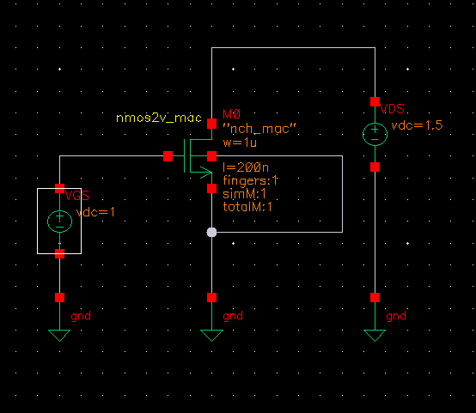

Figur 1 NMOS test bench schematic

### Subthreshold slope

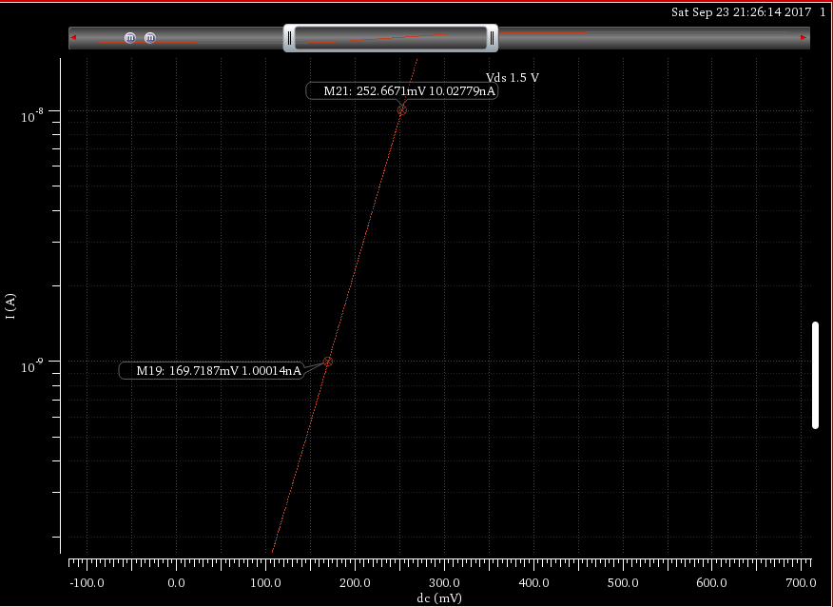

Figur 3 Subthreshold slope of the NMOS transistor

The subthreshold slope is fund be looking at the graph (Figur 2) in the subthreshold region where Vgs < Vth. To find the subthreshold you can measure the voltage difference between two decades. So, for our simulation the subthreshold slope is 252mV-169mV = 83mV/decade. The typical subthreshold at room temperature is around 60mV/decade.

### DIBL

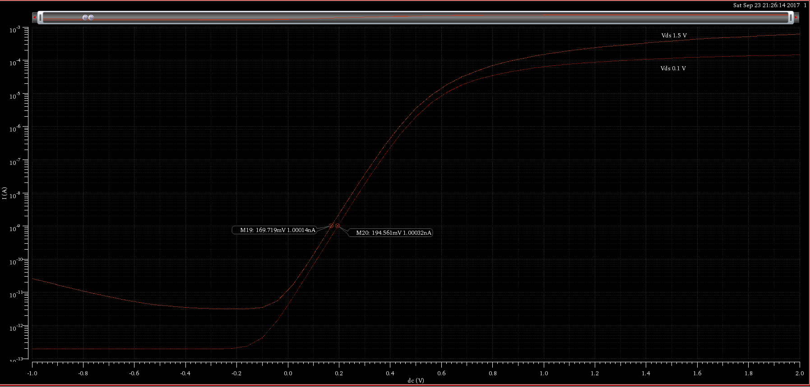

Figur 4 DIBL of the NMOS transistor with markers for the two threshold voltages

The DIBL(Drain-Induced Barrier Lowering) increases the drain source voltage leakage in transistors with short channels at low Vds voltage. By lowering the Vds voltage on the transistor and plot sweep on the same graph as your normal Vds. You can find the delta Vth and delta Vds and calculate the DIBL effect be this formula $DIBL=\frac{V_{th}^{ds}-V_{th}^{low}}{V_{ds}-V_{low_ds}}$. For our transistor (see Figur 3), the DIBL is

|  |  |  |
| --- | --- | --- |
|  | $$DIBL=(194.561mV-169.719mV)/(1.5V-0.1V)$$ |  |

$⇕$*Ligningen løses for DIBL vha. CAS-værktøjet WordMat.*

$$DIBL=17,74429·\frac{mV}{V}$$

### Ioff

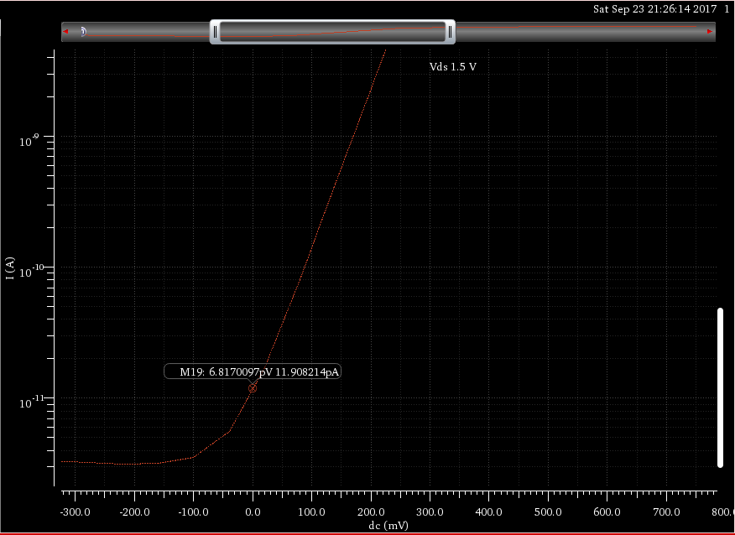

Figur 5 Ioff shown on the graph

The Ioff is the current leakage from drain to source when the gate voltage is equal to zero and the NMOS transistor is turned off. As seen in Figur 4 the Ioff for our simulated NMOS transistor is ~12pA.

### Threshold Voltage

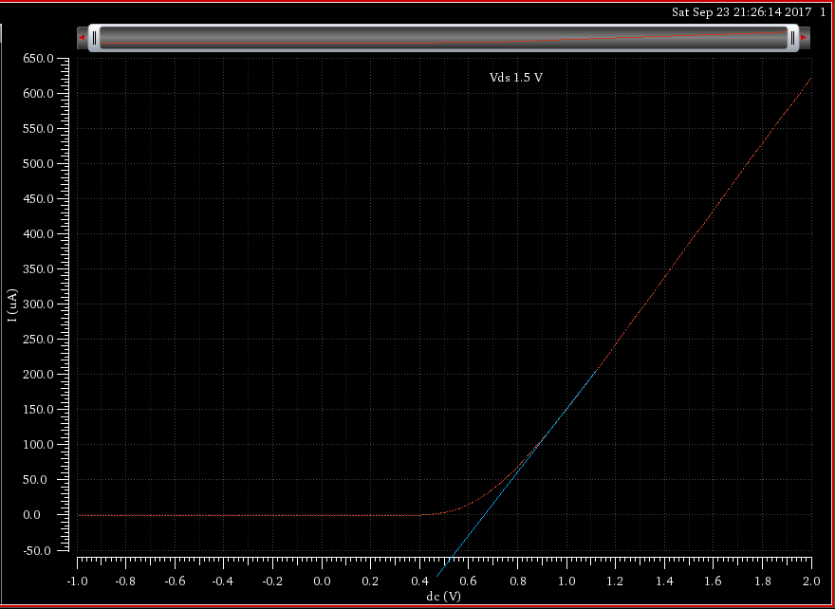

Figur 6 Threshold voltage of the NMOS transistor

To read a transistor threshold voltage from a linear graph. you draw a line from the straight part of the graph as seen on Figur 5. Where the line crosses the x axis you have your threshold voltage. In our case the Vth is ~539mV.

### Temperatur effects

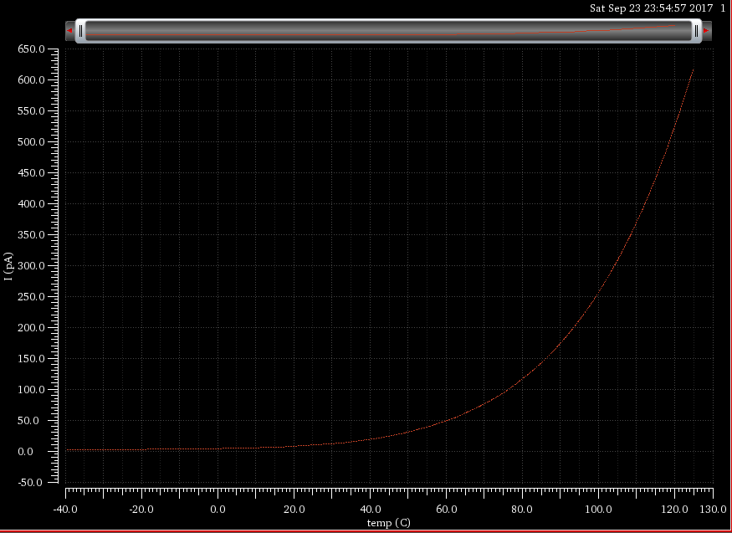

Figur 7 Temperature sweep of a NMOS transistor with Vgs=0V

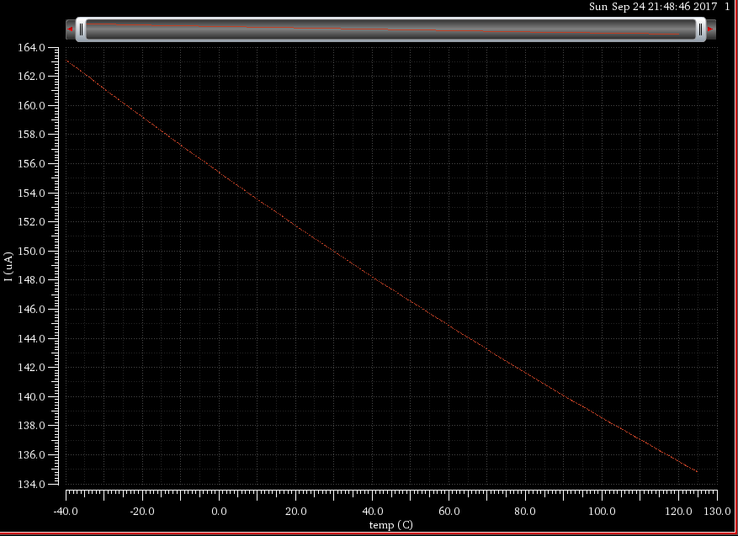

Figur 8 Temperature sweep of a NMOS transistor with Vgs > Vth

In the temperature sweep of the NMOS transistor with Vgs=0. You can see in the graph on Figur 6 that the Ioff increases when the temperature raises. In Figur 7 is show a graph of Ion vs temperature. For Ion the characteristic of current is inverted from Ioff meaning that with high temperature the transistor has a lower Vth and movement of electrons so isn’t as effective at higher temperatures.

### Body voltage effect on threshold voltage

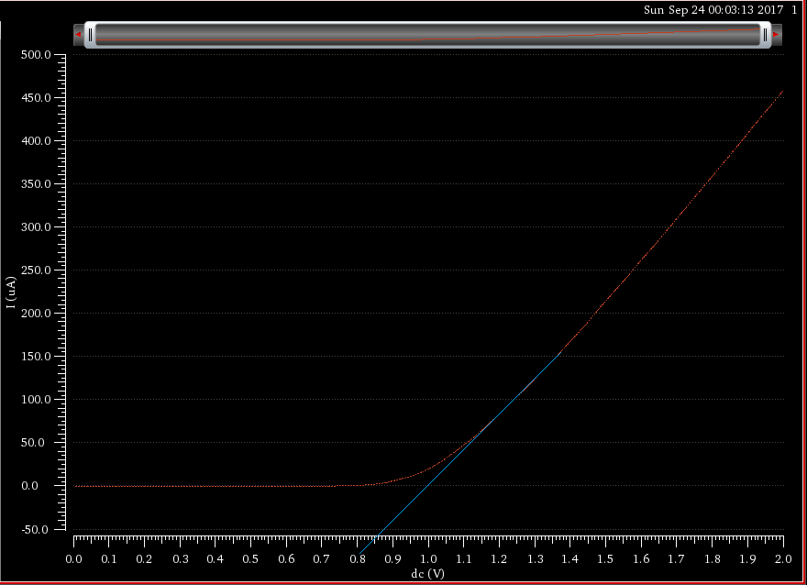

Figur 9 Threshold voltage increased after the Bulk is connected to Vdd instead of gnd

Be increasing the bulk voltage we can manipulate the threshold voltage of the transistor. As seen in Figur 5 the threshold voltage is increased to 860mV when the bulk gate is connected to Vdd instead of gnd.

### Channel length modulation coefficient